Azure Load Balancer – DEMO

Step-by-Step Configuration

1. Create a RG which will contain below resources using attached scripts.



Reourc Group = "LB-Demo"

Region / Location = "uksouth"

vnetName = "vnet_lb_demo" – CIDR Address Space – 10.0.2.0/23

subnetName= "vnet_lb_demo_subnet1" - CIDR Address Space – 10.0.2.0/24

VM1-Name = "LB_DEMO_VM1" #Ubuntu VM

VM2-Name = "LB_DEMO_VM2" ##Ubuntu VM

Network-Security-Group = "NSG_LB_Demo"

AvaolabilitySet = "AVSET_LB_Demo"

1. Log in to the Azure portal at  [https://portal.azure.com](https://portal.azure.com/).
2. Get the public IP of VM1 “LB_DEMO_VM1”
3. SSH to VM1 "LB_DEMO_VM1" as shown below

knallusa@LIN80032595 MINGW64 /c/Data/Samy/Pers/MyBuz/Trainer/Matrials/Azure

$ ssh admin11@20.68.200.64

The authenticity of host '20.68.200.64 (20.68.200.64)' can't be established.

ED25519 key fingerprint is SHA256:jLYOfJnltcBNYLjWqHCsiV4bfURcwIcnwrCQ7q4Y+bw.

This key is not known by any other names

Are you sure you want to continue connecting (yes/no/[fingerprint])? yes

Warning: Permanently added '20.68.200.64' (ED25519) to the list of known hosts.

admin11@20.68.200.64's password:

Welcome to Ubuntu 18.04.6 LTS (GNU/Linux 5.4.0-1089-azure x86_64)

1. And then run below scripts to **install Apache web server**

# INSTALLING APACHE

sudo apt-get update -y

sudo apt-get upgrade -y

sudo apt-get install apache2 -y

sudo chmod -R 777 /var/www/html # This need to run if you get error while running below cmd -

echo "Hello From VM 1" > /var/www/html/index.html

1. Get the public IP of VM2 “LB_DEMO_VM2” and repeat above step # 3 and 4.
2. Create below 2 inbound rules for Network-Security-Group "NSG_LB_Demo"

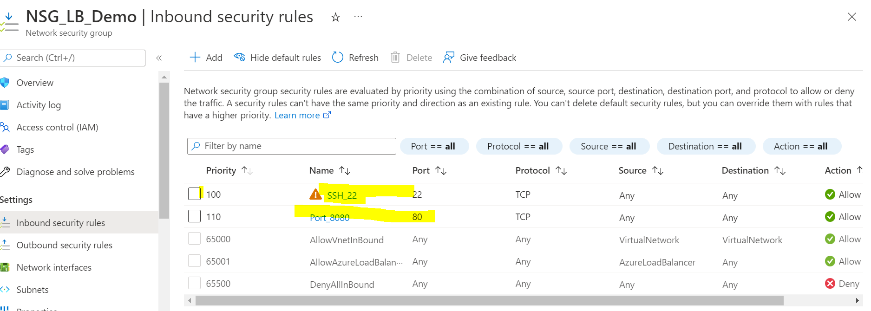

1. Create a Azure Load Balancer as shown below

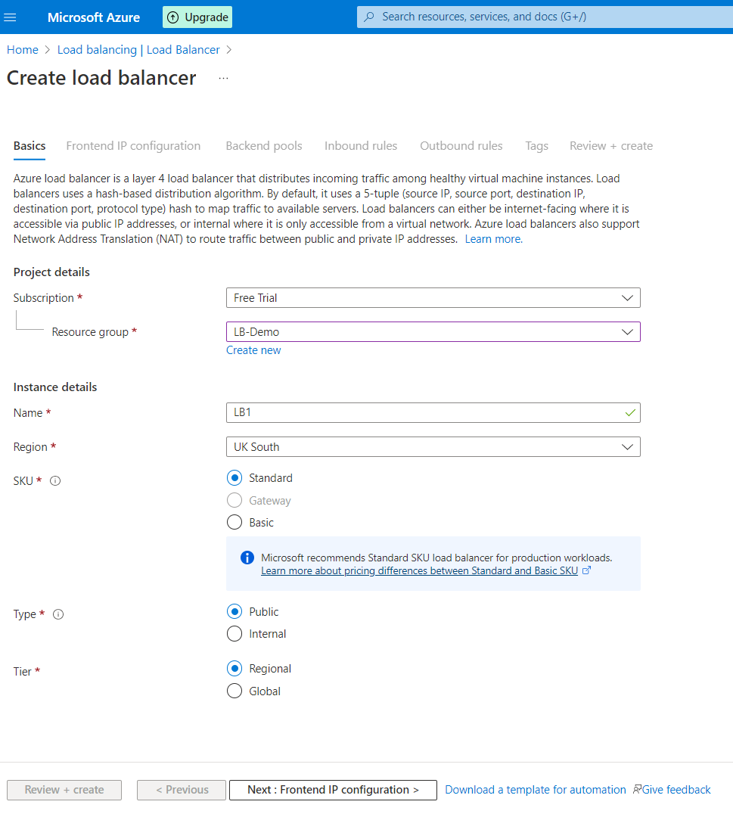

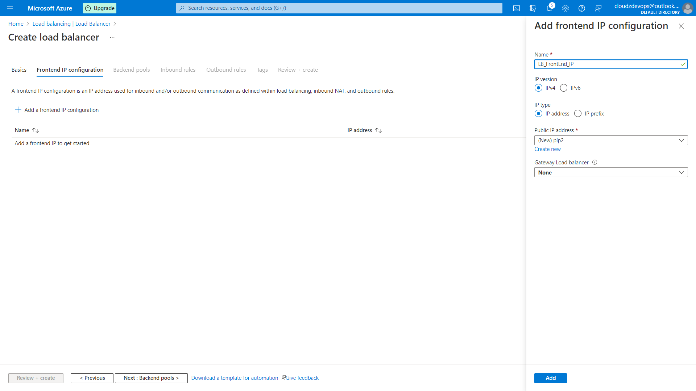

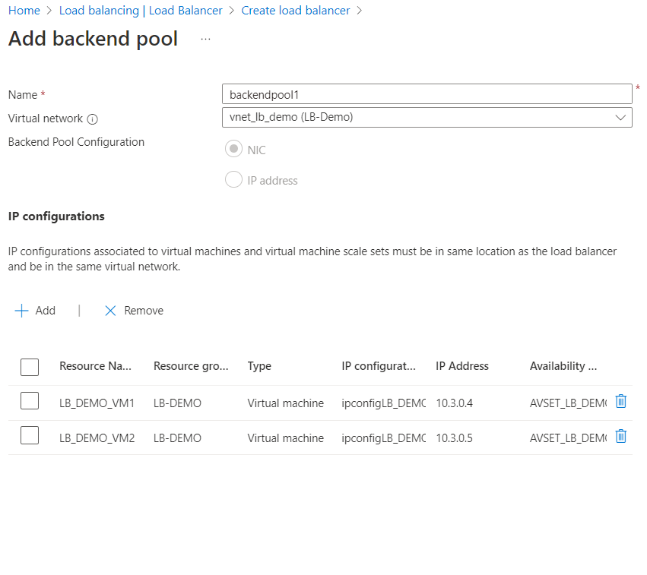

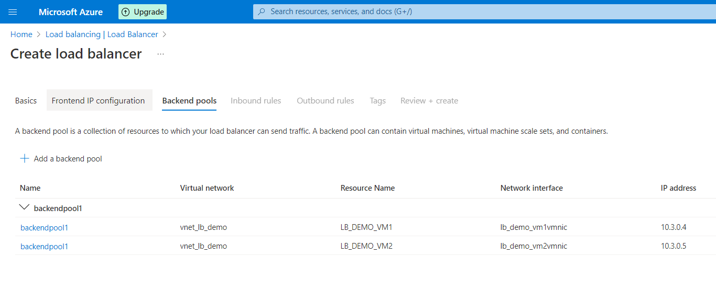

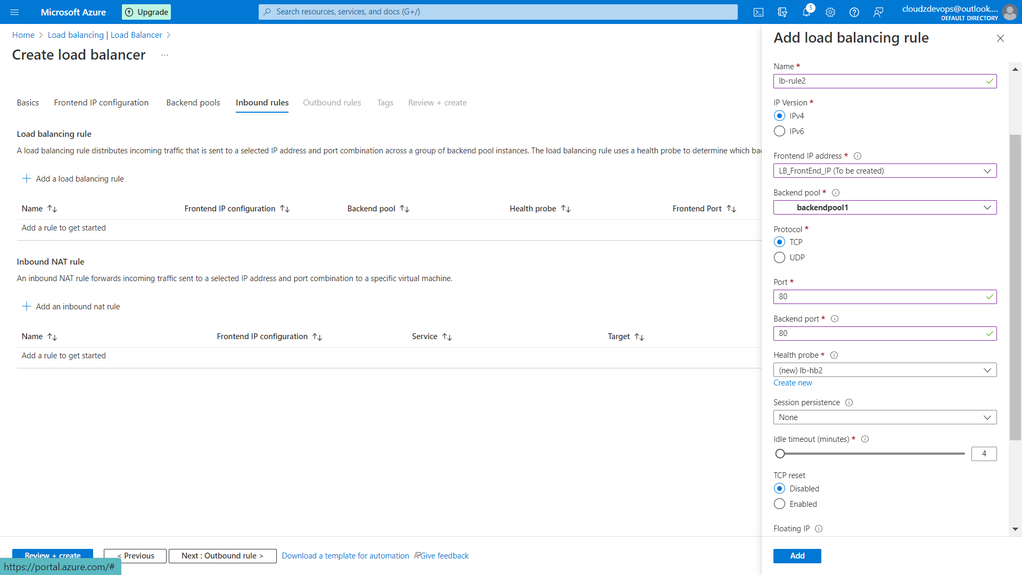

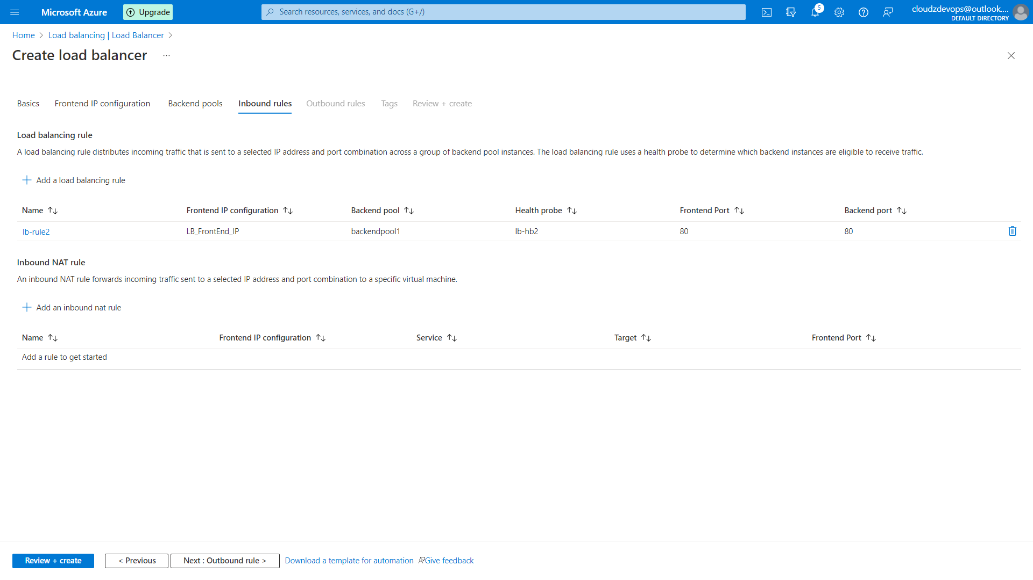

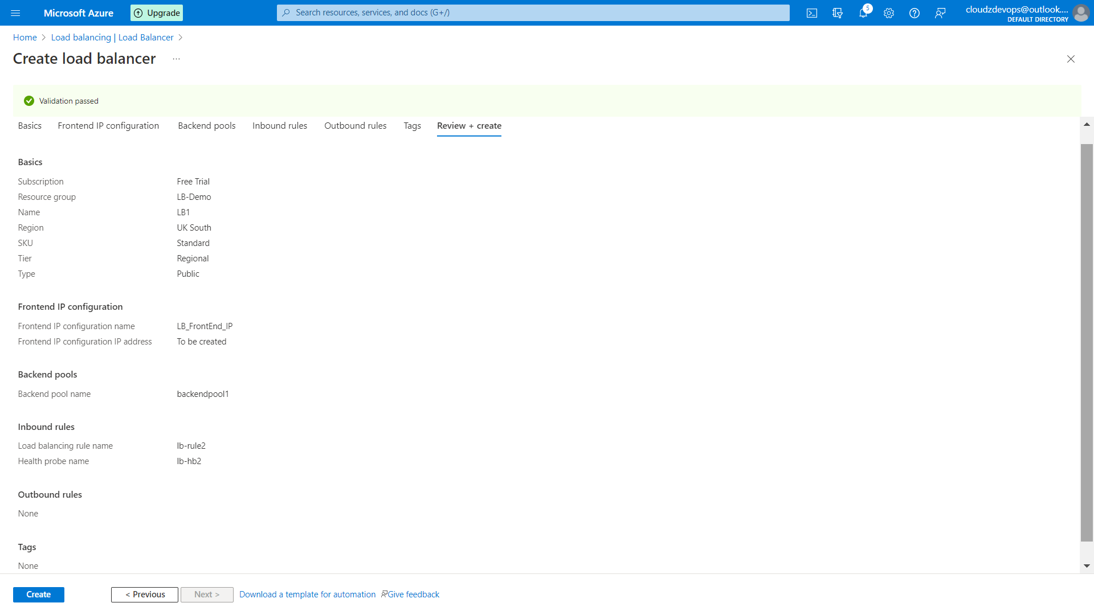

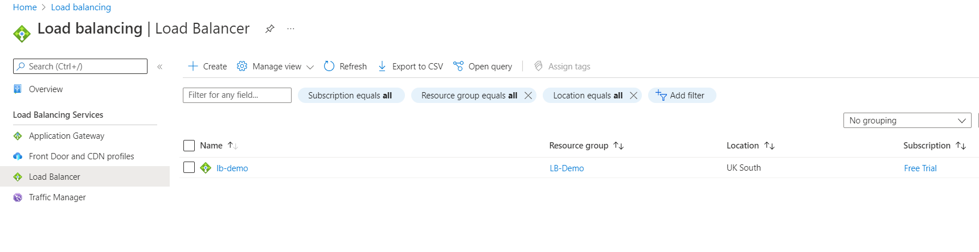

1. Get Frontend IP and access it from browser multiple times and ensure you get response from both VMs.

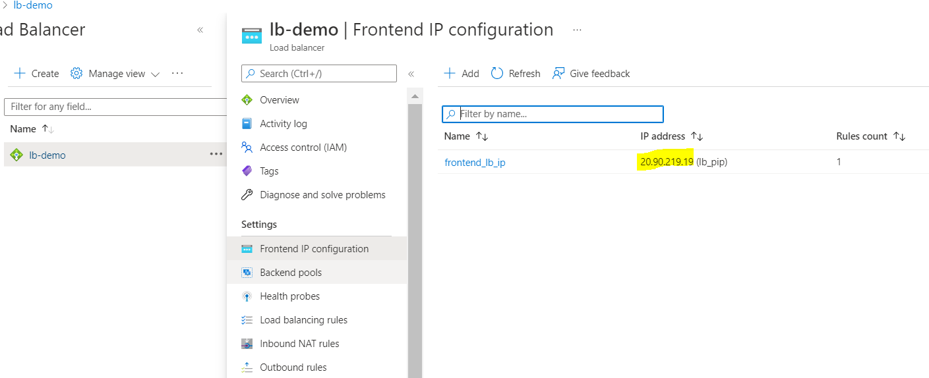

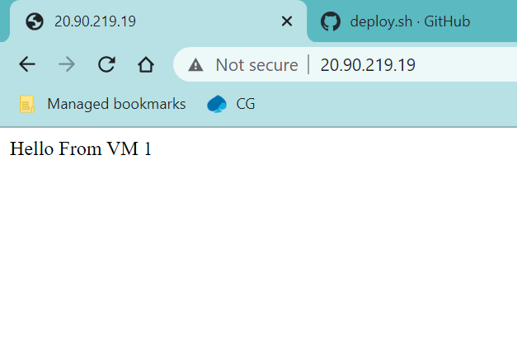

1. Since public facing LB has been configured successfully, you do not need now the public IP of VMs. So, Detach the public IP of VM as shown below and now access LB front end IP and ensure you can access websites.

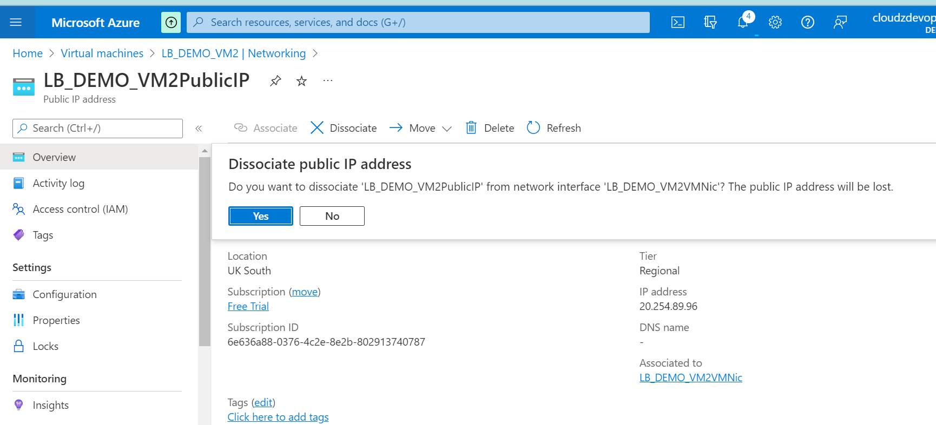

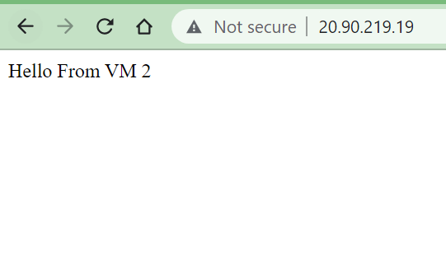

1. v